The Naval Stores Industry
Objectives: What were Naval Stores and why are they important to NC history and development?
Why is this field trip called Tar Heels Go Walking?
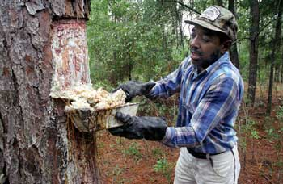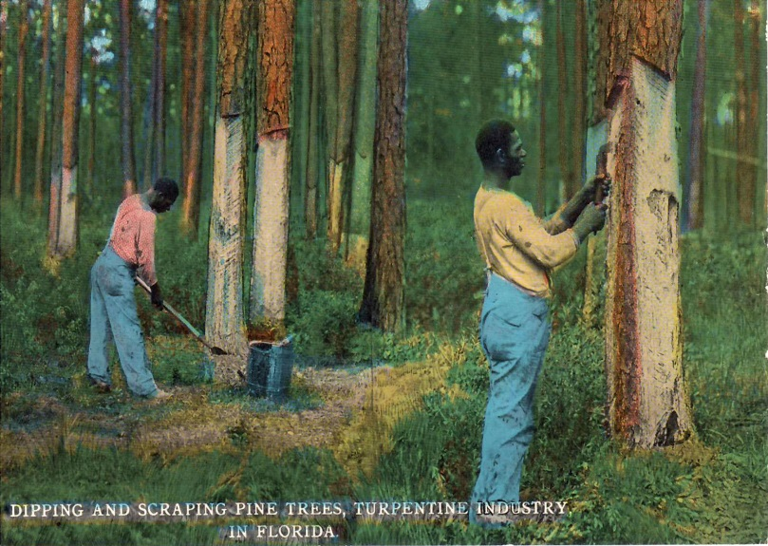
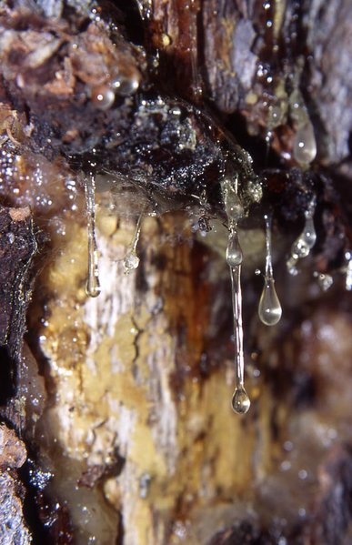
Resin – the sticky residue from Long Leaf Pines

*** Excellent North Carolina Video on Naval Stores: https://www.youtube.com/watch?v=pfFlCzjmmOw
Without question, one of the most important industries in the development of North Carolina and the Cape Fear region was the naval stores industry. The name naval stores can be confusing. While people living in the 1700’s and 1800’s used the term “stores,” in modern day we would use the word products. Simply put, naval stores started out as products that the British Navy used to help with their ships (some of the uses changed over time, but this is how the industry started).
England was a powerful nation during the 1700’s and 1800’s and to maintain that power, they had the largest navy in the world. At that time ships were made of wood, and it was discovered that the resin from longleaf pines trees could be turned into other products to help make ships more waterproof and last longer. It just so happened that North Carolina had a large, natural supply of longleaf pine trees – making the colony and later state, the number one exporter of naval stores in the Americas.
Four major products came from the sticky resin of the longleaf pine:
- Tar – a dark, thick, sticky liquid produced by burning pine branches and logs very slowly in kilns (ovens). Tar was used to coat sails, ropes and riggings of ships to make them last longer against the salt water, wind, and sun.
- Pitch – People learned that you could boil the tar and get a substance called pitch. This was used to help waterproof ships by spreading it between the wood cracks (much like caulk in modern times).
- Turpentine – could be used as lamp oil and in the creation of paints and rubber goods. Turpentine is still used today as paint thinner.
- Rosin – could be used to reduce the harshness of the lye soap that was popular at the time. Today, rosin is used by violinists on the bow to help produce sounds on the violin.

With England in desperate need of naval stores, the industry began exploding in North Carolina around 1720. By the 1770s, North Carolina was responsible for 70 percent of the tar exported from North America and 50 percent of the turpentine. Naval stores were the colony’s most important industry.
This industry was also a direct cause of the growth and development of the port city of Wilmington.
And perhaps most importantly, the nickname “Tar Heels” comes directly from the fact that North Carolina was such a huge supplier of naval stores. As people worked the naval store industry in the colony, many would step through excess (extra) tar on the ground and it was hard to get off. The nickname “Tar Heels” just became a common description for someone from North Carolina. Therefore the name of the field trip “Tar Heels Go Walking” comes from the importance of naval stores upon the state’s economy and development.

Producing the naval stores was very hard work and many land owners in eastern North Carolina brought in African slaves to help with the process.

With the invention of steel ships in the mid to late 1800s and the reduction of the amount of longleaf pine trees, the naval stores industry began to greatly decrease in the state, but it clearly made a lasting impact upon the development and culture of the state.

Images below…

North Carolina Naval Stores Map – this shows the areas that were the biggest producers of “Naval Stores.”
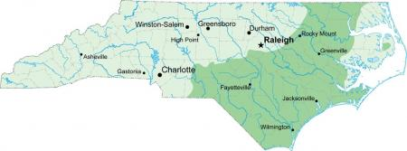

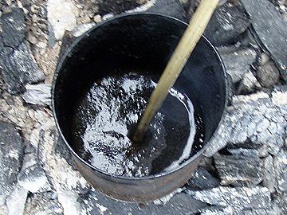
Tar
Pitch

